Digital Hose Display Fog Machine：

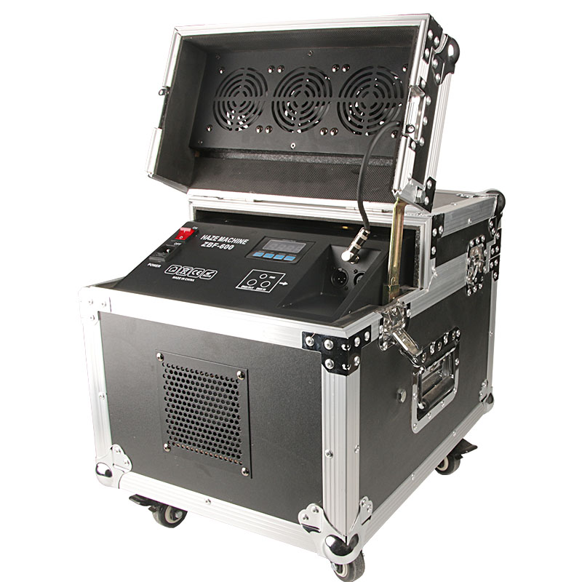

Digital code English
- UP - Heating
A 1-511 DMX address code
P 1-100 Puff QTY 1-100 adjust
D 1-200 Puff time 1-200 adjust
1 1-200 Space time 1-200 adjust

Standby mode when the digital hose strokes cycle working

1.Puff: Press up (on/off) work/stop, puff qty is the maximum when show P100.
2. Puff QTY adjust: Press the menu button to show P than press the up or down button then press the OK button to save
3. Puff time adjust：Press the menu button to display D, press the up or down button to adjust the range of 1-200 seconds, then press the enter button. Such as D, number eight is mean puff seconds.
4. Space time adjust: Press the menu button to display number one and press the up or down button to adjust the range of 1-200 seconds, then press the OK button to save. such as, number 5 is the space five seconds
5. Definite Time Definite Quantity: Press the down button (Definite Time Definite Quantity) work / stops. Smoke machine work automatically cycle according to set numerical of puff time and space time. Like three and four options, puff eight seconds and space five seconds
6.Remote Control：Puff QTY according to set parameter for work; such as puff QTY at 8%, puff QTY is P 8 when remote control
7.DMX：Automatic priority DMX, other function is disabled when DMX, press the menu key and press the up/down button, set address code, press the OK button to save.

